**Q1.**

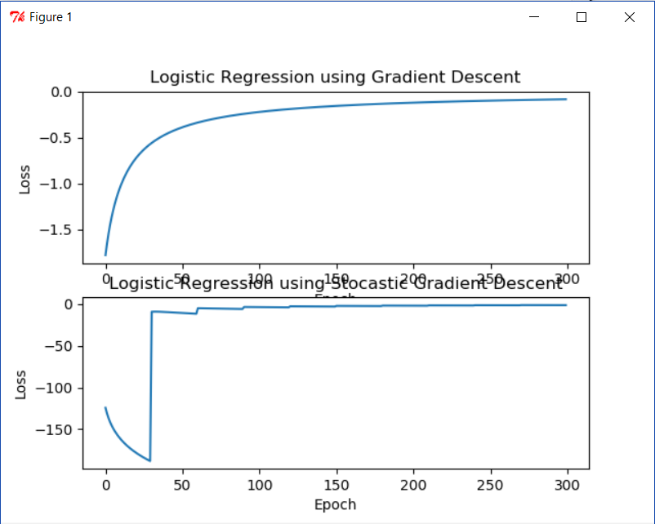

**Code:**

# -*- coding: utf-8 -*-

"""

Created on Thu Mar 1 12:13:14 2018

@author: tgore03

"""

import numpy as np

import matplotlib.pyplot as plt

from sklearn.linear_model import SGDClassifier

from sklearn.linear_model import LogisticRegression

import random

from sklearn.metrics import log_loss

#Generate Data

mu, sigma = 0.5, 0.3

s1 = (np.random.randn(100, 2) / 10) + 0.5

s2 = (np.random.randn(100, 2) / 10) - 0.5

y1 = np.ones(100)

y2 = np.zeros(100)

x = np.vstack((s1, s2))

y = np.hstack((y1, y2))

#Train Logistic Regression Model

def sigmoid(scores):

return 1 / (1 + np.exp(-scores))

def log_likelihood(features, target, weights):

z = np.dot(features, weights)

ll = np.sum( target*z - np.log(1 + np.exp(z)) )

return ll

def logistic_regression(features, target, num_steps=30000, learning_rate=0.001, add_intercept = False):

#Preprocess data

if add_intercept:

intercept = np.ones((features.shape[0], 1))

features = np.hstack((intercept, features))

weights = np.zeros(features.shape[1])

#Initilize variables

i=0

loss = [None]*(num_steps)

epoch = [None]*(num_steps)

#Train Model

for step in xrange(num_steps):

#Predict based on current weights

z = np.dot(features, weights)

predictions = sigmoid(z)

# Update weights with gradient

output_error_signal = target - predictions

gradient = np.dot(features.T, output_error_signal)

weights += learning_rate * gradient

# Print log-likelihood every so often

loss[i] = log_likelihood(features, target, weights)

epoch[i] = i;

i+=1

#Plot Loss w.r.t. iteration

global plt

plt.subplot(211)

plt.plot(epoch, loss)

plt.xlabel('Epoch')

plt.ylabel('Loss')

plt.title('Logistic Regression using Gradient Descent')

return weights

def stocastic_logistic_regression(features, target, num_steps=30000, batch_size=10, learning_rate=0.1, add_intercept=False):

#Preprocess data

if add_intercept:

intercept = np.ones((features.shape[0], 1))

features = np.hstack((intercept, features))

weights = np.zeros(features.shape[1])

#Initilize variables

i=0

data_size=len(features[:,0])

steps_per_epoch = data_size/batch_size

no_of_epoch = num_steps/steps_per_epoch

print no_of_epoch

loss = [None]*(no_of_epoch)

epoch = [None]*(no_of_epoch)

#Train Model

index=0;

for step in xrange(num_steps):

x = features[index:index+batch_size]

y = target[index:index+batch_size]

index = index+batch_size

#Predict based on current weights

z = np.dot(x, weights)

predictions = sigmoid(z)

# Update weights with gradient

output_error_signal = y - predictions

gradient = np.dot(x.T, output_error_signal)

weights += learning_rate * gradient

# Print log-likelihood after each epoch (Obtained by len(features)/batch_size)

if step % data_size/batch_size == 0:

loss[i] = log_likelihood(features, target, weights)

epoch[i] = i;

i+=1

index=0

#Plot Loss w.r.t. iteration

global plt

plt.subplot(212)

plt.plot(epoch, loss)

plt.xlabel('Epoch')

plt.ylabel('Loss')

plt.title('Logistic Regression using Stocastic Gradient Descent')

plt.show()

return weights

#Define figure for plot

global plt

plt.figure(1)

#Train using Gradient Descent

print "Training using Gradient Descent"

weights = logistic_regression(x, y, num_steps = 300, learning_rate = 0.1, add_intercept=True)

#Train using Stocastic Gradient Descent

print "Training using Stocastic Gradient Descent"

weights = stocastic_logistic_regression(x, y, num_steps = 2000, batch_size=30, learning_rate = 0.1, add_intercept=True)

**Q2)**

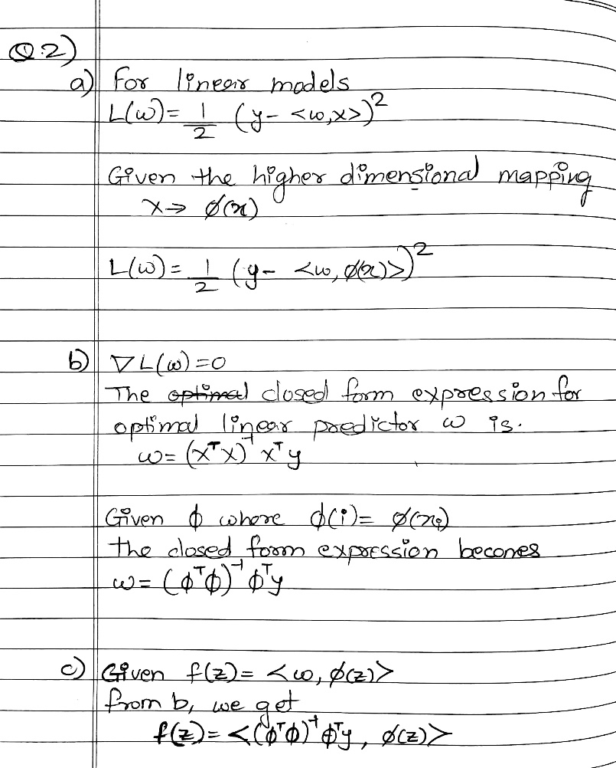

**Q3)**

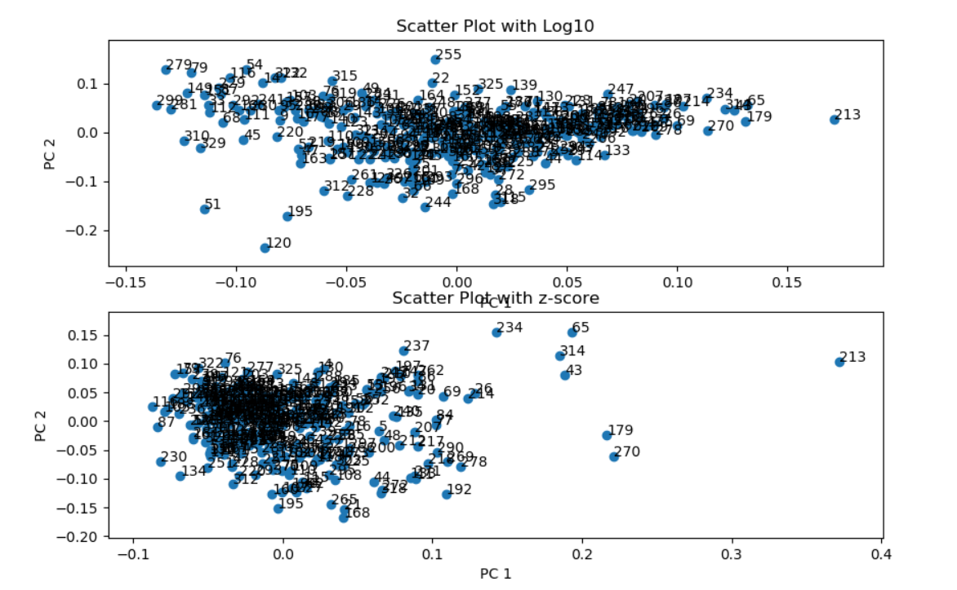

**With Log10 Normalization:**

Principle Directions:

1. [ 0.03507288 0.09335159 0.40776448 0.10044536 0.15009714 0.03215319 0.87434057 0.15899622 0.01949418]
2. [ 0.0088782 0.00923057 -0.85853187 0.22042372 0.05920111 -0.06058858 0.30380632 0.33399255 0.0561011 ]

The two components appear to correlate most with HealthCare and Arts

Variance of each features is :

[ 8.40161907 1.85948255 0.68742394 0.83689849 0.61121211 0.40852812

0.26982829 0.13831459 0.06133763]

Outlier Cities:

1. 213 - New-Orleans,LA
2. 120 – Gary-Hammond,IN
3. 51 – Brockton,MA
4. 195 – Middletown,CT

**With Z-score Normalization:**

Principle Directions:

1. [ 0.20641395 0.35652161 0.46021465 0.28129838 0.35115078 0.27529264 0.46305449 0.32788791 0.13541225]
2. [ 0.21783531 0.250624 -0.29946528 0.35534227 -0.17960448 -0.48338209 -0.19478992 0.38447464 0.47128328]

Variance of each feature is:

[ 11.57517228 43.0323617 41.5675071 33.35398373 27.25678957 22.21711637 18.02308595 11.5894271 4.40125211]

Since the variance of each feature does not vary much projection on 2d causes lot of data to be lost. Hence the 2d plot cannot be trusted to accurately represent the data.

Outlier Cities:

1. 213 – New-Orleans,LA
2. 270 – San-Diego,CA
3. 179 – Lorain-Elyria,OH
4. 43 – Boise-City,ID
5. 314 – Waco,TX
6. 65 – Chattanooga,TN-GA
7. 234 – Peoria,IL

**Code:**

import numpy as np

import math

import matplotlib.pyplot as plt

from sklearn.decomposition import PCA

from sklearn.decomposition import TruncatedSVD

f = open("places.txt", "r")

no_features = 9

no_records = 329

features = np.empty([no_records, no_features])

target = ["" for x in range(no_records)]

#Read the labels

f.readline()

#Read the file

lineno=-1

colno=-1

i=0

for line in f:

lineno+=1

for word in line.split():

#Store label column

if colno == -1:

colno+=1

target[lineno]=str(word)

continue

colno+=1

#Skip last 5 columns

if colno > no_features:

break;

#Store word in matrix

features[lineno,colno-1] = word

colno=-1

i+=1

f.close()

print "PCA using Log10"

#Taking log of matrix

x = np.log10(features)

#Taking mean of features and subtracting it from the features matrix

means = np.mean(x, axis=0)

std = np.std(x, axis=0)

for i in range(no_records):

x[i]=(x[i] - means)

#SVD

u,s,v = np.linalg.svd(x, full_matrices=True)

d = np.diag(s[0:2])

scores = np.dot(u[:,0:2],d)

print "Principle Directions"

print v[0]

print v[1]

svd = TruncatedSVD(n_components=9)

svd.fit(x.T)

print "Variance of indivial features"

print svd.explained_variance_

print "Total Variance of Principle Components =", svd.explained_variance_ratio_.sum()

#Plot the 2 principle components

components = svd.components_.T

plt.subplot(211)

plt.scatter(components[:,0], components[:,1])

for row in range(no_records):

plt.annotate(str(row+1), (components[row,0], components[row,1]))

plt.xlabel("PC 1")

plt.ylabel("PC 2")

plt.title("Scatter Plot with Log10")

print "\n\n PCA using z-score"

#using z-scores normalize data

means = np.mean(features, axis=0)

std = np.std(features, axis=0)

for i in range(no_records):

for j in range(no_features):

x[i][j]=(features[i][j] - means[j])/std[j]

u,s,v = np.linalg.svd(x, full_matrices=True)

print "Principle Directions:"

print v[0]

print v[1]

svd = TruncatedSVD(n_components=9)

svd.fit(x.T)

components = svd.components_.T

print "Variance of each features: \n",svd.explained_variance_

print "Total variance of Principle components =",svd.explained_variance_ratio_.sum()

plt.subplot(212)

plt.scatter(components[:,0], components[:,1])

for row in range(no_records):

plt.annotate(str(row+1), (components[row,0], components[row,1]))

plt.xlabel("PC 1")

plt.ylabel("PC 2")

plt.title("Scatter Plot with z-score")

plt.show()

**Q4)**

I spent about 20hrs on this assignment.

**References:**

Discussed with Nitesh Gupta however I completed my assignment on my own.